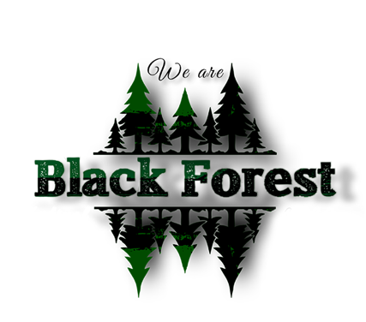

2022 Black Forest Festival Sponsorship Opportunities
Gold Sponsorship: $600.00 or sponsorship in kind
-Sponsor logo and sponsorship level to be included in large hanging banner displayed outside Black Forest Community Center during festival. *
-Sponsor logo and brief profile included on the festival website (WeAreBlackForest.com) with a link back to sponsor website or Facebook page.
-Sponsor to be recognized as Gold Sponsor on the 2022 Black Forest Festival Facebook Event.
-Gold Sponsors will be promoted on the Black Forest Festival & More Facebook page (1,350+ followers). Gold Sponsors will receive six (6) dedicated Facebook posts leading up to the festival. Content and schedule will be determined jointly between sponsor and Tiffany Coles (Black Forest Festival Lead Marketing Volunteer).
-Sponsor will receive a complimentary standard booth during the festival exhibit hours. **
-Opportunity to participate in the Black Forest Festival Outhouse Race.
-Each Gold Sponsor will receive a framed festival picture to proudly display in their place of business.
Silver Sponsorship: $400.00 or sponsorship in kind
-Sponsor logo and sponsorship level to be included in large hanging banner displayed outside Black Forest Community Center during festival. *
-Sponsor logo and brief profile included on the festival website with a link back to sponsor website or Facebook page.
-Sponsor to be recognized as Silver Sponsor on the 2022 Black Forest Festival Facebook Event.
-Silver Sponsors will be promoted on the Black Forest Festival & More Facebook page (1,350+ followers). Silver Sponsors will receive three (3) dedicated Facebook posts leading up to the festival. Content and schedule will be determined jointly between sponsor and Tiffany Coles (Black Forest Festival Lead Marketing Volunteer).
-Opportunity to reserve an exhibitor booth at a discount of $20.00 off the standard rate. **
-Opportunity to participate in the Black Forest Festival Outhouse Race.
-Each Silver Sponsor will receive a framed festival picture to proudly display in their place of business.
Bronze Sponsorship: $200.00 or sponsorship in kind
-Sponsor logo and sponsorship level to be included in large hanging banner displayed outside Black Forest Community Center during festival. *
-Sponsor logo and brief profile included on the festival website with a link back to sponsor website or Facebook page.
-Sponsor to be recognized as Bronze Sponsor on the 2022 Black Forest Festival Facebook Event.
-Opportunity to participate in the Black Forest Festival Outhouse Race. **
-Each Bronze Sponsor will receive a framed festival picture to proudly display in their place of business.

*Sponsorship level must be determined, and business logo submitted by July 15th, 2022, to allow time for design and printing.
**Sponsor must determine if they want to participate in the Outhouse Race and if they want the complimentary or discounted booth space at the time of contract (if applicable to sponsorship).

I would like to sponsor the 2022 Black Forest Festival!

My sponsorship level is:
Gold Sponsor
Silver Sponsor
Bronze Sponsor
Other Amount $____________

Please detail arrangements of sponsorship in kind (if applicable):

My primary point of contact/s regarding sponsorship details and deliverables is:

Name:
Phone:
Email:
Name:
Phone:
Email:
2022 Black Forest Festival Sponsorship Agreement
The Black Forest Festival Committee and {Sponsor}, enter into this agreement freely and willingly on the {date} day of {month}, {year}. The terms of this agreement are as follows:
The Event
Sponsor agrees to provide sponsorship for the 2022 Black Forest Festival.
The Sponsorship
Sponsor agrees to provide Committee with agreed upon sponsorship amount or terms of sponsorship in kind.
Credit
In exchange for this sponsorship, Committee agrees to provide Sponsor with items included in their sponsorship level or items agreed upon for sponsorship in kind.
Delivery
Sponsor agrees that sponsorship amount will be delivered to the Committee no later than July 15, 2022. Committee agrees that all sponsorship items will be delivered on or before the 2022 Black Forest Festival.
Relationship
This agreement represents the only relationship between the Black Forest Festival Committee and Sponsor. No other relationship between the two entities exists, implied or otherwise.

____________________________ ____________________________
Sponsor Name Sponsor Signature

____________________________ ____________________________
Festival Committee Representative Name Festival Committee Representative Signature
*Please make checks out to “Black Forest Community Club” with “2022 Black Forest Festival Sponsorship” in the memo. For additional questions, please email WeAreBlackForestCO@gmail.com.

